1. select \* from salgrade;

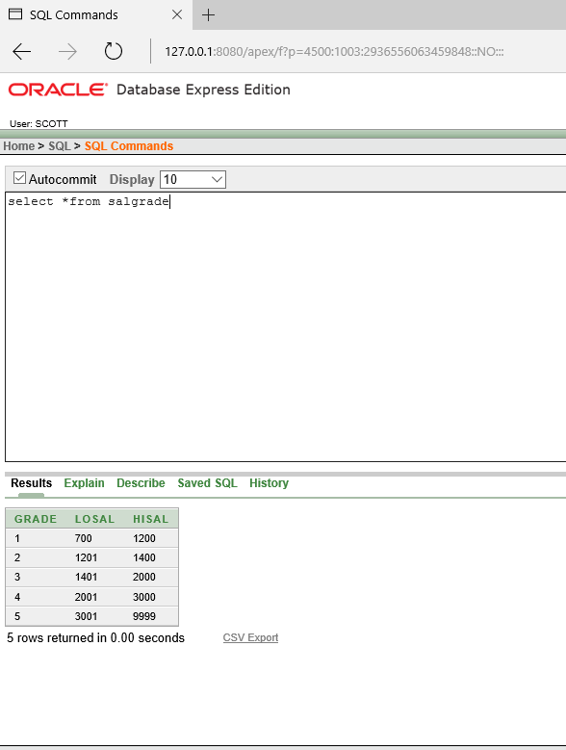

1. select deptno from dept;

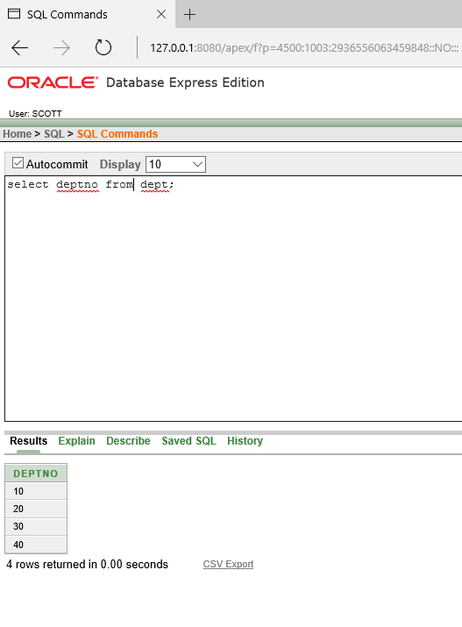

1. select (sal+sal\*0.05)"5% Increment" from emp;

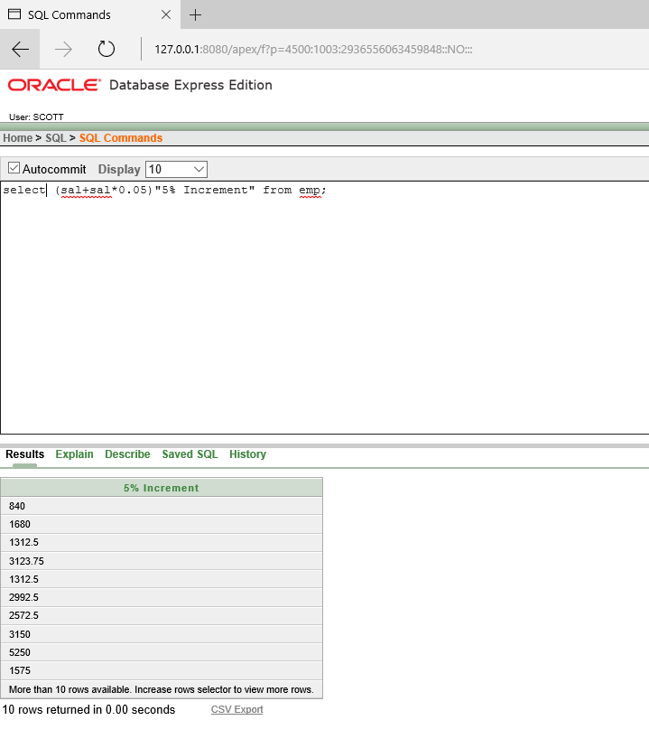

1. select ename, sal, (sal+sal\*0.05)"5% Increment" from emp;

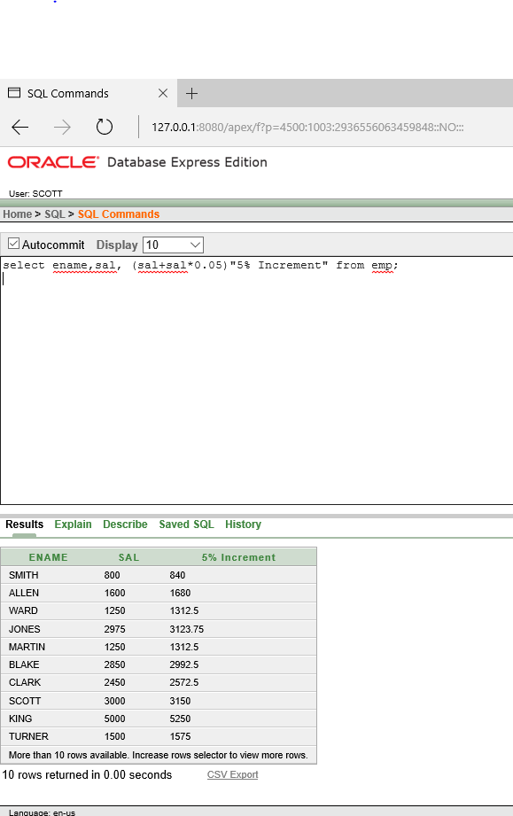

1. select \*from emp where ename ='BLAKE'

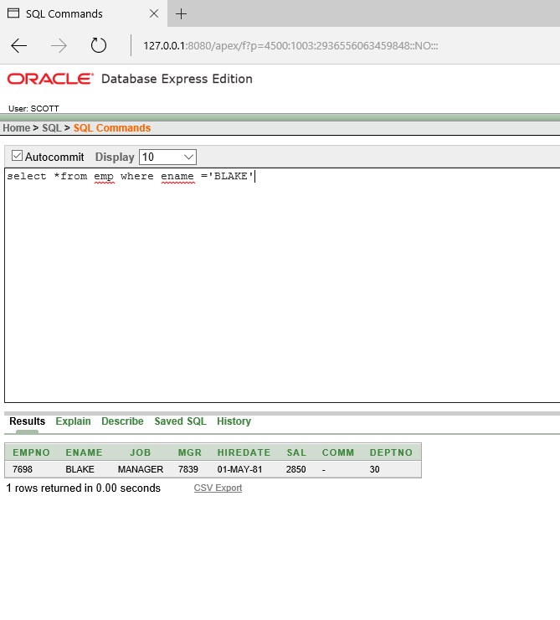

1. select ename||'is hired on' ||hiredate||'as a'||job"Description" from emp where hiredate between '17-dec-80' and '28-sep-81';

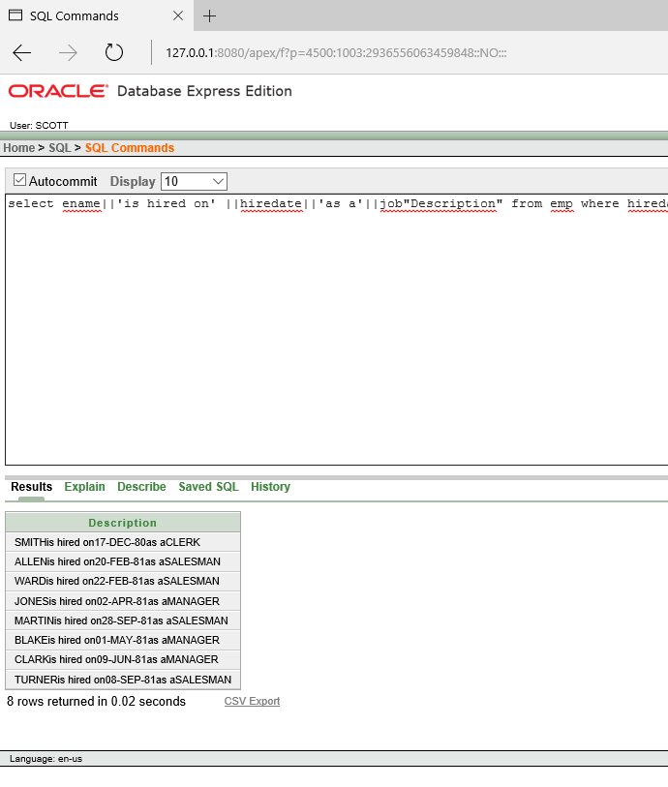

1. describe emp;

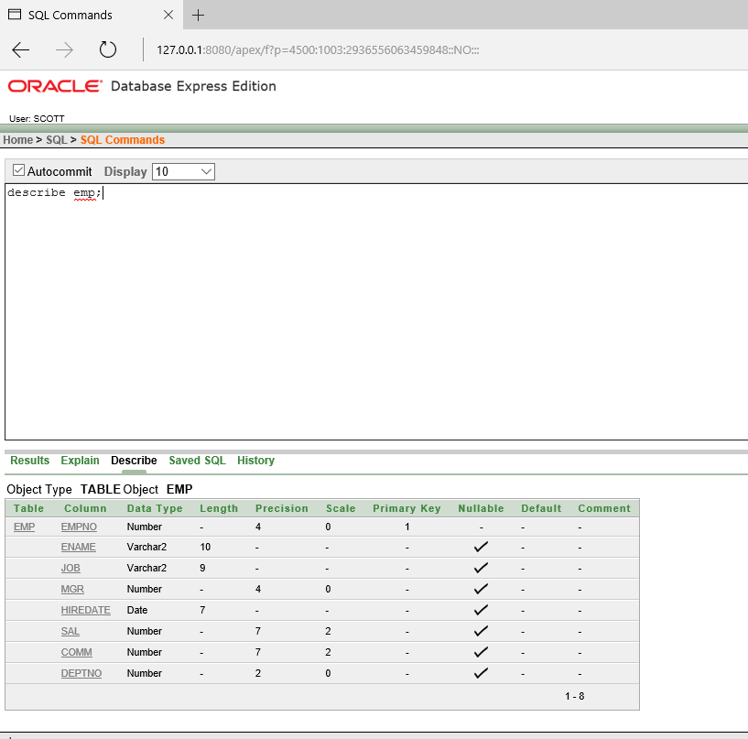

* 1. describe dept

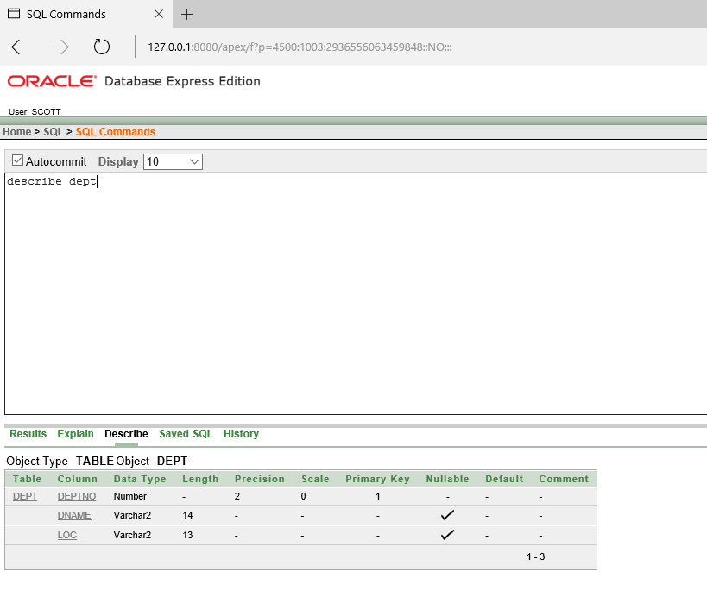

* 1. describe salgrade;

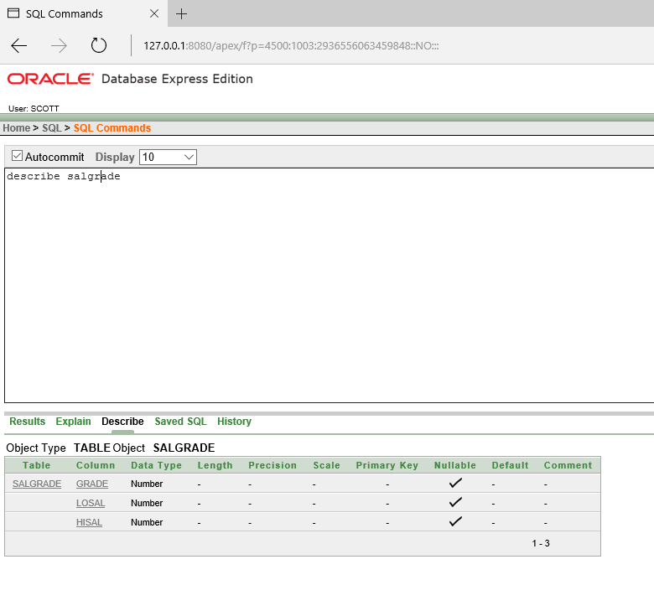

* 1. describe bonus

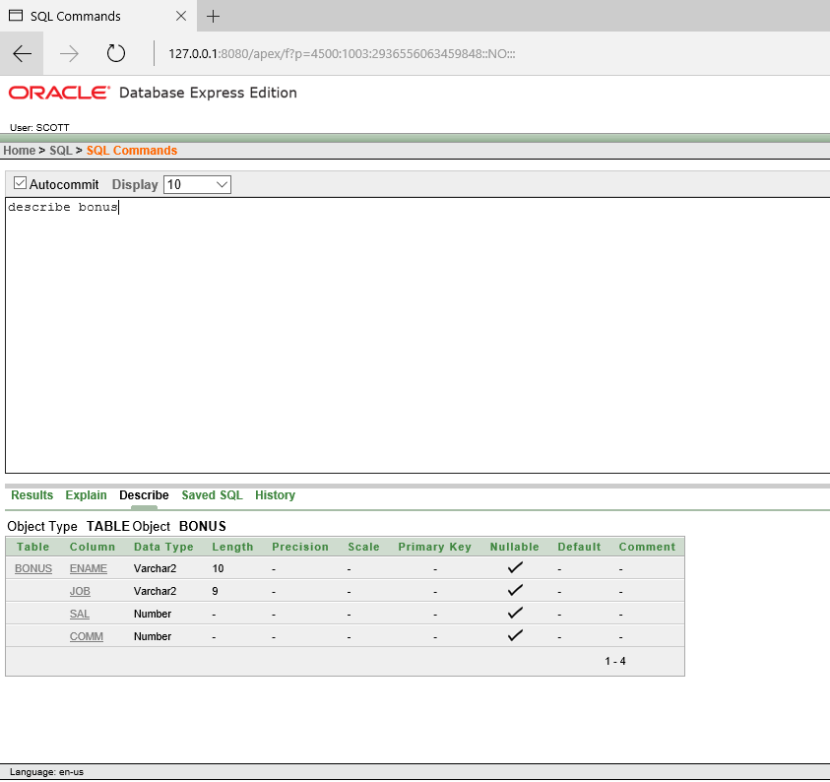

1. select DISTINCT job from emp;

